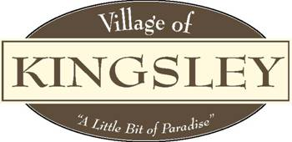

Planning Commission
Agenda
207 S. Brownson Ave
Kingsley, MI 49649
April 26th, 2023

Meeting Called to Order

Pledge of Allegiance

Roll Call: Bott , Forro , Jeffreys , Nickerson , Smith , Weger Willman .

Also Attending: Manager Aldrich , ZA Williams Ab .

Public in Attendance:

- Motion to approve March 22nd, 2023 minutes.
- Additions or Deletions to April 26th, 2023 Agenda.
- Motion to approve the April 26th, 2023 Agenda
- Conflict of Interest.
- Public Comment – General.
- Public Comment – Agenda items
- Presentations:

FYI:
- 2022 Village of Kingsley Planning Commission Annual Report

New Business:
- Government for Tomorrow – Liam Dreyer
- Ordinance re-approvals and schedule Public Hearing
  - §152.115 Commercial C-1
  - §152.005 Zoning Code Definitions for Dwelling Units
  - §93.13 Garage Sales
  - §22-06 Gross Density
  - §152.005 Impervious Surfaces
  - §92.06 Impervious Surfaces
  - §93.11 (C) Noise Prohibited

Old Business:
- Master Plan
- Capital Improvement Plan

Committee Reports:
- Village Manager – Kaitlyn Aldrich
2. Village Council – Eric Weger
3. Village Zoning Administrator – Roger Williams
a. . March 2023 Zoning Reports
4. RRC Ad Hoc Committee Update – Chris Bott

Adjournment: Motion to adjourn meeting

